Tyler Brisbin

Assignment 1 results

H1B completed decode function:

void decode(){

int bit = -1; int k = 0;

while ((bit = inputBit()) >= 0){

// your four lines of code?

k = codetree[k][bit];

//Move down the code tree with index k until a leaf is reached.

if (codetree[k][0] == 0) {

System.out.write(codetree[k][1]);

k = 0;

}

//Output symbol needs to start moving again from root of the tree

}

System.out.flush();

}

Image of decompressed file:

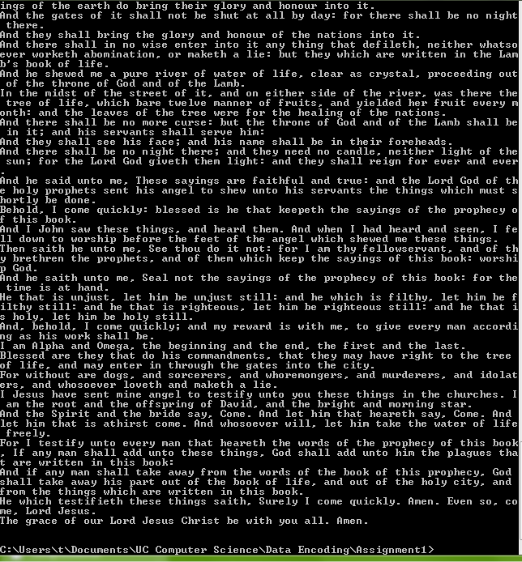

Compression ratio:

The original compressed file was 2,250,651 bytes. Uncompressed, the file size was 4,077,778 bytes. The compression ratio is 8 \* (2,250,680) / 4,077,778 bytes, or a ratio of approximately 4.415 bits per byte. Since entropy is the lower bound of the compression ratio, the compression ratio cannot fall lower than the entropy. The entropy calculation for the uncompressed file was 4.374, which is lower than the compression ratio. The difference between the two values is only 0.041, or a percent difference of only 0.933%. The compression ratio is still greater, which verifies the theorem that the compression ratio, or average path length, is greater than or equal to the entropy.